Contents
1.0 Core problem definition 2
2.0 Common features of existing platforms 2
3.0 Target users and their needs 3
3.1 Student 3
3.2 Tutor 3
3.3 Administrator 4
4.0 Tech stack 4
5.0 Project requirements 5
5.1 Functional Requirements 5
5.2 Non-Functional Requirements 6
5.3 User interface 6
5.4 Landing page 7
5.4 Student interface 7
5.5 Tutor interface 7
5.6 Admin interface 7
6.0 Problem areas 7
6.1 Data security and privacy 7
6.2 Payment services and calendar integration 7
6.3 Performance and scalability 8
6.4 System integration 8
6.5 User acceptability 8
Chapter 3: Architecture design and algorithm explanation 9
3.1 System Architecture 9
3.2 System Functionality 10
3.2.1 Registration and login [2,3,4,5,6,7,8,9] 10
3.2.2 Tutor searching 12
3.2.3 Lesson booking 12
3.2.4 Webchat 12
References 13

1.0 Core problem definition
Many parents recognise the benefits of music tuition for their child e.g. inculcating good habits of goal-orientated practice, persistence, increased self-confidence, socialisation, and demonstration of extra-curricular activities for application to school or University. Older students may use it to pursue a new hobby, or a career in music via recognised qualifications.
Tutors and students face numerous obstacles when arranging lessons. Tutors may have difficulty finding students if they rely on word-of-mouth or if their local area is saturated with competitors. Managing schedules can be problematic due to having to juggle numerous students and, without an effective system, can run the risk of double-bookings or being unaware of cancellations and losing potential income.
Students and their parents or guardians can struggle to find tutors meeting their needs in terms of instrument, skill level, availability, and a child’s special needs. Parents may find it difficult to assuage safeguarding concerns with an unknown adult as tutor advertisements can be vague on personal details. They may also have concerns over quality due to a lack of tutor reviews. Without a real-time means of communication and an integrated calendar system, scheduling may be particularly difficult for parents trying to juggle work and personal commitments. Finally, both tutors and students can run into issues if there is no integrated payment processing system and a clear cancellation policy.
With these challenges in mind, the task is to build a modern, responsive web application that simplifies the process for tutors and students. The platform should allow tutors to advertise their services, level of expertise, pricing information, location, and easily manage their schedules. For students, they should be able to quickly and easily locate tutors matching their requirements, and book and pay for lessons. The system should facilitate quick communication between both parties for initial and continued communications.

2.0 Common features of existing platforms
The problem is not novel and that there exist numerous sites or apps that seek to meet the needs of tutors and students. The common features of some of these platforms^{1,2,3} are as follows:
- The landing page gives an overview of the searching, booking and payment process for students.
- The sites state that teachers are vetted for safety in working around children.
- A search function allowing prospective students to find tutors by instrument, location, solo or group lessons, pricing, online or site-based teaching, by student skill level, and student accessibility needs e.g. ADHD.
- Before students can contact tutors, they must sign up and register via email.
- There is a messaging system allowing communication between student and teachers
- Students can see tutor availability and pay for lessons individually or as a block
While these features are essential for such a platform, there are opportunities to improve upon the sites’ functionality and user experience. The aim of this project, therefore, is to build a modern platform that possesses all the necessary features whilst addressing their common shortcomings. By focusing on ease-of-use, streamlining the booking and paying processes, and enhancing communication, the platform will offer tutors and students a more efficient and user-friendly choice to fulfil their needs.

3.0 Target users and their needs
To facilitate system design, I will consider 3 fictional users: a student, a teacher, and an administrator, and their needs from the system.

3.1 Student
In this context a student will represent an adult seeking lessons, or a parent seeking lessons for their child.
Student user requirements
- A student will want to search for potential tutors based on preferred instrument(s), the student’s skill level, the tutor’s skill level, pricing, location, availability, review ratings, ability to work with children with SEN.
- View matching tutor profiles and, once registered, contact the tutor to discuss potential lessons.
- View tutor’s current availability but not have access to or be able to amend other students’ booking details.
- Book lessons directly into tutor’s diary and complete secure payment there and then to secure the slots.
- Receive confirmation of booking.
- Cancel lessons and receive refunds in line with cancellation policy.
- Be able to flag inappropriate tutor profiles or messages.

3.2 Tutor
A tutor will be any adult wishing to offer lessons. Their main requirements from the system are as follows:
Tutor user requirements
- Register and create a detailed profile page displaying relevant personal info, instruments taught, levels taught, location, pricing etc
- Upload proof of qualifications and CRB/vetting checks.
- Use an in-built scheduling system where the tutor can set their availability and be notified of any bookings made by students.
- Amend availability and cancel lessons
- Use an instant, two-way messaging system for communication with students and receive notifications of student and admin messages.
- Have the platform handle payments and refunds on behalf of the tutor.
- View payment history and earnings.

3.3 Administrator
Administrators will be employees of the fictional company behind the app who will have special privileges and responsibilities relating to the system.
Administrator requirements
- Manage tutor and student accounts to include approving or rejecting registration requests, deactivating accounts, and resetting passwords.
- Review tutor profiles, including uploaded documents, behavioural flags from students or from tutors, and remove inappropriate content and accounts.
- View all lesson-booking activity and amend bookings.
- View all messages in the two-way messaging app.
- Receive notifications of flagged behaviour from students or tutors.
- Monitor payment transactions and have access to financial information used on the site.
- View site analytics such as user activity, booking trends, and payments made.
By clearly defining user needs, the system can be designed to ensure that it works appropriately for all and that it can meet their requirements. User experience will be an important consideration on top of the core user needs so that the final system is functional and user-friendly.

4.0 Tech stack
Building such a large project requires numerous development tools for front-end, back-end , and the database. The chosen tools and reasoning are as follows:
- React.js
React is a modern, well-maintained, well-documented, and in-demand library with numerous add-on libraries designed to extend functionality. It is built around the paradigms of component-based-architecture and single-page applications where developers create re-usable UI components that efficiently update in response to data changes. React also integrates well with express.js.
- React router
React router is a library specifically designed to simplify client-side routing in react. It allows dynamic navigation and nested routes as well as handling data fetching and loading for components.

- React hook form and Zod
React-hook-form is a library specifically designed to simplify the implementation of user forms in react. It reduces re-renders and integrates easily with schema validation libraries like Zod.

- Tailwind CSS
Tailwind is a popular CSS framework that integrates particularly well with react. It is used to create modern, responsive UIs using pre-defined classes for styling. It will reduce the need for custom CSS.
- Express JS
Express JS is one of the most popular frameworks for building web servers and APIs. It greatly simplifies routing compared to node.js and, like react, has many libraries to extend functionality or take care of security e.g. passport, bcrypt. It integrates easily with databases like PostgreSQL.
- PostGreSQL
PostGreSQL was chosen primarily as it is a relational database that lends itself well to structured data and integrates easily with express via the ‘pg’ library. MongoDB was excluded as it is noSQL.
- Miscellaneous
Other technologies to be used include GitHub for version control [ADD EXTRA PACKAGES HERE]

5.0 Project requirements
To meet user needs, the platform must meet certain functional and non-functional requirements. These requirements will form the basis for system design and testing.

5.1 Functional Requirements
- User registration and authentication:
The system will allow users to register, log in, and manage their profiles securely. This includes email verification and password recovery.
- Search and filter functionality:
Students must be able to search for tutors based on instrument, location, skill level, pricing, availability, and special educational needs (SEN) accessibility. The search results should dynamically update based on filter selection
- Tutor profiles:
Tutors will be able to create detailed, editable profiles that include relevant personal information, location, qualifications, CRB/vetting checks, teaching level, availability, SEN compatibility, and pricing.
- Booking system:
The platform will allow students to book lessons directly based on a tutor’s availability. Once a lesson is booked, both the student and tutor will receive confirmation through email and the system’s notification feature.
- Messaging system:
A secure, two-way messaging system will allow students and tutors to communicate directly on the platform to discuss lessons or answer queries. Notifications will be sent for new messages.
- Payment and refund processing:
Students will pay for lessons through a secure payment gateway, and tutors will receive payments automatically. The platform will handle refunds in accordance with cancellation policies.
- Admin oversight:
Admin users will be able to manage user accounts, approve tutor profiles, review flagged content, and moderate communications between users.

5.2 Non-Functional Requirements
- Performance:
The platform should quickly return search results and profile pages.
- Security:
User data, including passwords and payment details, will be encrypted and secure payment gateways will be used.
- Scalability:
The platform will be designed to scale as the user base grows. This includes supporting more tutors and students without impacting performance or system stability.
- Usability:
The platform will feature a modern, responsive, user-friendly interface that can be navigated easily by non-technical users. It will work across both desktop and mobile devices.

5.3 User interface
The UI must be intuitive, user-friendly, responsive, and designed to meet the needs of users. Users should be able to easily navigate the system and complete their intended tasks efficiently regardless of the device they are using. All pages will have consistent branding and colour and formatting.

5.4 Landing page
The entry point for all users. It will have a clean and simple design and will summarise the platform’s purpose and key features. There will be prominent buttons or tabs to guide the user to register, login, find a tutor etc.

5.4 Student interface
Students will be able to access a dashboard allowing them to search for tutors. Once a tutor is selected, students can view their card containing detailed relevant info, send messages, book and pay for lessons, and receive conformation of booking. A simple booking and payment gateway will be integrated in to the interface.

5.5 Tutor interface
Tutors interface will display their profile, upcoming lessons and availability, notifications, and means to check earnings. After registration approval, tutors will be able to create and amend their profile They will be able to use the inbuilt messaging system to communicate with students and administrators.

5.6 Admin interface
The admin interface will give access to user management tools for approving or rejecting tutor registrations, viewing tutor profiles and removal of any flagged content, deactivating accounts, verifying upload documents. Admins will also have access to site analytics.

6.0 Problem areas
With a project of this scope, there are foreseeable challenges.

6.1 Data security and privacy
The system will process a lot of personal and sensitive information such as CRB checks, payment details etc. Any data breach in real life would result in reputational damage, regulatory fines, and loss of customers. To mitigate this, the platform will employ industry standard encryption and user authentication.

6.2 Payment services and calendar integration
These features will be too complex to design from scratch so 3rd party payment gateways and calendar systems will need to be integrated. This will also require robust testing to ensure correct integration and performance.

6.3 Performance and scalability
The system will need to remain performant even as user-base increases and not become slow or unresponsive especially at times of peak demand. Demonstrating this may be difficult for a project of this relatively small scale, but efforts will be made to incorporate characteristics of scalability by making server-side code efficient and to have database indexing etc.

6.4 System integration
The platform will have many ‘moving parts’ e.g. messaging system, search feature, scheduling tool etc. To improve testability and code manageability, a modular approach will be taken where each component can be coded and tested before integration with another.

6.5 User acceptability
Even if all the previous areas are handled well, it will not mean much if the site is unintuitive, hard to use., or fails to meet customer expectations. As such, it will be designed using modern front-end tools, and there will be clear information given to users as to how the site works and how to use it to fulfil their needs.

Chapter 3: Architecture design and algorithm explanation
This chapter describes the architecture and key internal mechanisms of the Music Tutor Platform. It provides a high-level overview of the main system components, how they interact, and detail of the most significant code underpinning the system’s functionality.

3.1 System Architecture
React [1,2]
The frontend is implemented as a React single-page-application (SPA) that renders the user interface using reusable components. Components make extensive use of the inbuilt React functions (hooks) of useState for maintaining and updating component data, useEffect for fetching from the API, and useContext to provide app-wide access to user data and chat state to support authorisation as well as webchat functionality. React-hook-form and Zod are used to build forms and validate client-side form input respectively.
React router [3,4,5,6,7]
Client-side navigation is managed with the react-router package. Its Route component is used to define routes on the frontend that are associated with React components to be rendered. The key benefit is that react router allows users to switch between pages without full page reloads thereby reducing load times.
Node/Express API [1,38]
A node server built using the express framework exposes REST APIs. The server defines all the endpoints and routing. Requests are handled via modularised route controllers that enforce business logic. Custom authentication and authorisation middleware are also used. There is a global error handler that standardises error response to frontend so as not to expose sensitive information. Having dedicated endpoints with specific data requirements and defined responses supports maintainability and testing. The webchat functionality of socket.io is mainly set up on the server. Both Express and Socket.io have CORS configured to allow cross-origin requests between React and the server.
PostgreSQL [8,9,10,11,12]
PostgreSQL is used for persistent data storage. Data includes student and tutor personal details, instruments taught, skill levels taught, lesson bookings, and chat messages. Primary keys, foreign keys, and constraints are used to enforce data integrity and reduce accidental deletion of data. PostgreSQL is accessed by the API via the PG module using pre-defined environment variables and the PG package’s ‘Pool’ class. For security, PG’s parameterised queries are employed when using client-side data in order to prevent SQL injection attacks.
Socket.io and Socket.io-client
Real-time chat functionality is achieved through socket.io and custom middleware on the server-side and socket.io-client on the client-side. In contrast to the HTTP request-response cycle, socket.io uses websockets to allow low-latency bi-directional communication between the server and client. Webchat access, database persistence, and message routing are mediated through JWT authentication. Full webchat functionality is implemented through pairing of a series of specific event listeners and emitters between server and client.
Json Web Token [13,14]
JWT is used for authentication and session handling between the client and server. Upon successful login, the server generates a token whose payload is an object with a unique user-id from the database. The token is signed cryptographically using the process.env.JWT_SECRET variable. It is set to expire after 24 hours and is stored in the browser as an HTTPOnly cookie. Being is a security feature that prevents the cookie contents from being read by client-side HTTPOnly JS. The cookie is sent to the server on subsequent fetch requests, via {credentials:’include’}, is verified server-side and the user_id is used to rebuild the logged-in user’s details in the req.user and socket.user objects.
Bcrypt
For security, all passwords during registration and login are handled using bcrypt salting, hashing and verification rather than being stored as plaintext. During login, the user details are obtained from the DB via form-submitted email, and the submitted password is compared with the password stored in DB via bcrypt.
CORS [15,16,17]
As the frontend and backend are on different ports, CORS restrictions apply and must be managed. This is achieved by configuring settings for the express server and socket.io server instance using the CORS package. The settings specify that the frontend’s origin, its credentials, and particular HTTP requests are acceptable. Without these permissions, the app would not work.

3.2 System Functionality
This section will explain in detail the implementation of the key functionality of registration and login, lesson booking, and real-time webchat.

3.2.1 User registration [18,19,20,21,22,23,24,25,26]
User registration is split in to tutor and student paths. Tutor registration is carried out through two-step form filling controlled by a step state variable. The first step collects tutor’s instrument, teaching format, teaching types, and skill levels. The second step collects personal details and allows submission.
Form input state and validation are handled using React-Hook-Form (RHF) with a bespoke Zod validation schema that is integrated with RHF via ZodResolver. As the form is large, fields are validated as soon as the user leaves an input to provide immediate corrective feedback. Validation errors are displayed inline in red via RHF’s formState.errors object. At transition to step two, step one’s fields are validated using RHF’s trigger() method. This prevents unfilled step-two fields from triggering validation errors before they have been shown to the user.
To ensure input of city and instrument data that is consistent with the format in the DB, the component uses useEffect hooks to fetch reference lists from the database and stores them in as arrays in state (dbCities and dbInstruments). As the user types, input is read via RHF’s watch function and a new dropdown display array is created by filtering the relevant array to include only partial matches. Selecting the item populates the field using RHF’s setValue function. See appendix for more detail on the code.
On submission, RHF passes the validated data to its onSubmit function which sends a POST request to the tutor registration endpoint with relevant HTTP content headers and a JSON body payload. Server-side validation is performed in the tutorRegistrationController handler, and the tutor is registered via SQL transaction. See appendix for the code used for registration.
If the server response is positive (includes new user id) a window alert is displayed to confirm successful registration. See Fig 3.1 for a sequence diagram of the process.
Student and admin registrations follow the same process but use fewer fields and post to a different endpoints.
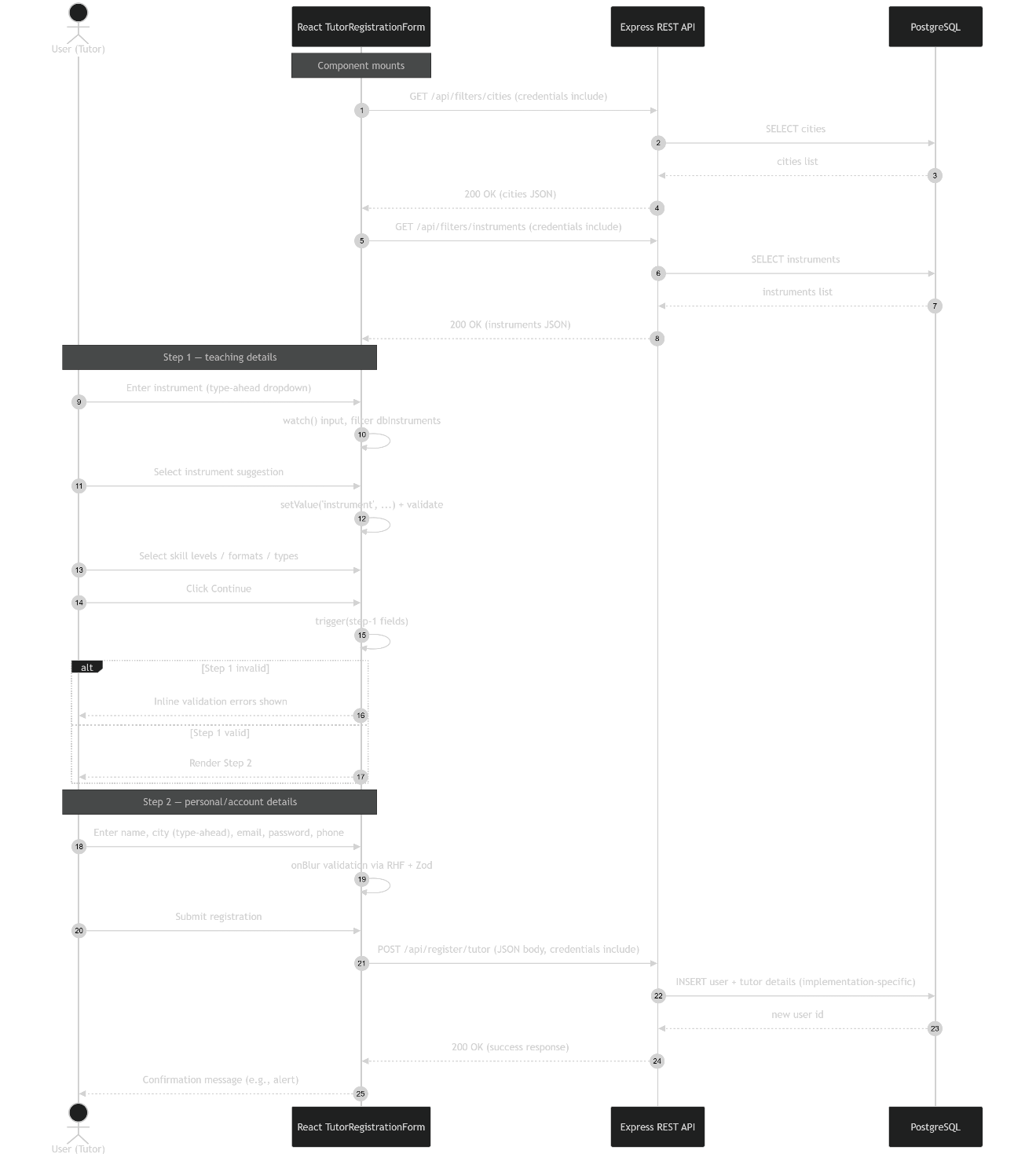
Fig 3.1- Tutor registration sequence diagram

3.2.2 User login
User login is simpler as it only requires two fields: email and password. On submission, the form sends the credentials to the login endpoint. The login controller validates that the fields are present and attempts to match the email with the email of a registered user in DB. If matched, it then uses Bcrypt to check the hashed DB password with input password. If correct, then a frontend-safe strippedUser object is created and the user id is used in the creation of a signed JWT and the token stored in an HTTP-only browser cookie as described earlier. Crucially, this user object is sent to the frontend which persists it in the UserContext state and is then used to allow access to protected features such as webchat communication from students to tutors and booking of lessons.

3.2.3 Tutor searching [27,28]
To search for tutors, a user clicks on the ‘Find a tutor’ link in the navbar. This navigates to a page that presents all tutors and allows users to filter by instrument and city or to click on a profile directly to be taken to that tutor’s page. The component transforms user input into a search request through a sequence of state changes.
User input is first written in to input state by the handleChange event handler. Crucially, the input does not directly trigger a search but is used to generate a real-time autocomplete dropdown by filtering lists of instruments and cities fetched when the component first loads. When the user presses the Enter key, the commitFilters function reads the input and writes it to the browser’s query string using React Router’s setSearchParams hook which triggers a navigation. Then a useEffect hook dependant on searchParams writes the state in to filters. A second useEffect, dependant on filters.city and filters.instrument, then uses URLSearchParams to build a query string for a fetch request. The returned tutor data is stored in state and rendered on screen as matching tutor results. See appendix for code

3.2.4 Lesson booking [29,30,31,32,33,34,35,36,37,38]
On the frontend, the TutorProfilePage is the parent component for the booking functionality. On load, it fetches the tutor’s personal data and confirmed lesson bookings, stores necessary state, and passes relevant props to its child components FocusedTutorCard and BookingCalendar. It also initialises a draftBooking state object which holds booking data to be built up across the components before a valid, full object is submitted to the backend. Via conditional rendering, the full functionality is only available if a student is logged in.
The FocusedTutorCard component displays the tutor’s lesson options: format, instrument, teaching type, and teaching level. To book a lesson, a student must choose one of each of the options. On clicking an option, the passed-down updateDraftBooking function updates the draftBooking object with the student’s choice.
In parallel, the BookingCalendar component allows the student to select available slots by clicking and dragging across a desired timeslot in 15-minute intervals. Availability is indicated by white coloured slots, and grey coloured slots indicate times that are no longer available. The calendar also displays previously confirmed appointments as a visual aid so that users don’t double-book. On choosing a slot, the handleSelectSlot function updates the draftBooking object by adding the chosen start and end times.
Before a booking can be confirmed, the frontend carries out a series of validation checks on the draftBooking object using the preBookingChecks function. These checks ensure that the slot is not in the past, does not overlap with a confirmed booking, that start is before the end, and that duration is 30-60 minutes. The confirm button is only enabled when all required booking fields are filled in; this prevents incomplete or invalid bookings being sent to the backend. Draft bookings are sent to the backend in the confirmDraftBooking function; it converts the start and end times from Date objects, required by react-big-calendar, to ISO strings for the database and sends POST request to backend.
When the POST request is received, the booking process is handled by the makeBooking route controller. It receives the draftBooking object and checks that all required fields are present, that required ID fields are positive integers and converts the booking times back into Date objects to perform the same validity checks as frontend. If these checks pass, it then checks the database for overlap with any conformed bookings. Only if all checks pass is the booking inserted into database and the newly created booking, with booking id, is returned to frontend tutorBookings state for display on the calendar. This allows the calendar to display the confirmed booking immediately without another fetch. These backend checks ensure that the backend is the final authority for making bookings.
The BookingCalendar component also allows students to view the details of confirmed lessons. When clicking on a lesson, the handleSelectEvent function sends a fetch request to obtain the full booking details from the database using the booking_id. The details are then displayed in a lessons-detail panel beneath the calendar.
If a confirmed booking is selected, there is an option to cancel so long as the booking is not beginning within 24 hours. This rule is enforced on the frontend by preventing clicking of the cancellation button, a warning message is displayed in the lesson-details panel, and these bookings are styled differently compared to bookings that can be cancelled (light blue vs dark blue).
On the backend, cancellation requests are handled by the cancelBookingById controller which validates the booking id, then updates the booking status to cancelled, via PATCH request, only if it exists in the database and starts in more than 24 hours (enforced using PostgreSQL interval function). If no row update occurs, the controller runs various checks against the database in order to provide detailed responses to the frontend. If the cancellation is successful, the frontend removes the cancelled booking from state so the calendar display updates immediately.
Full functionality is summarised in Fig 3.2
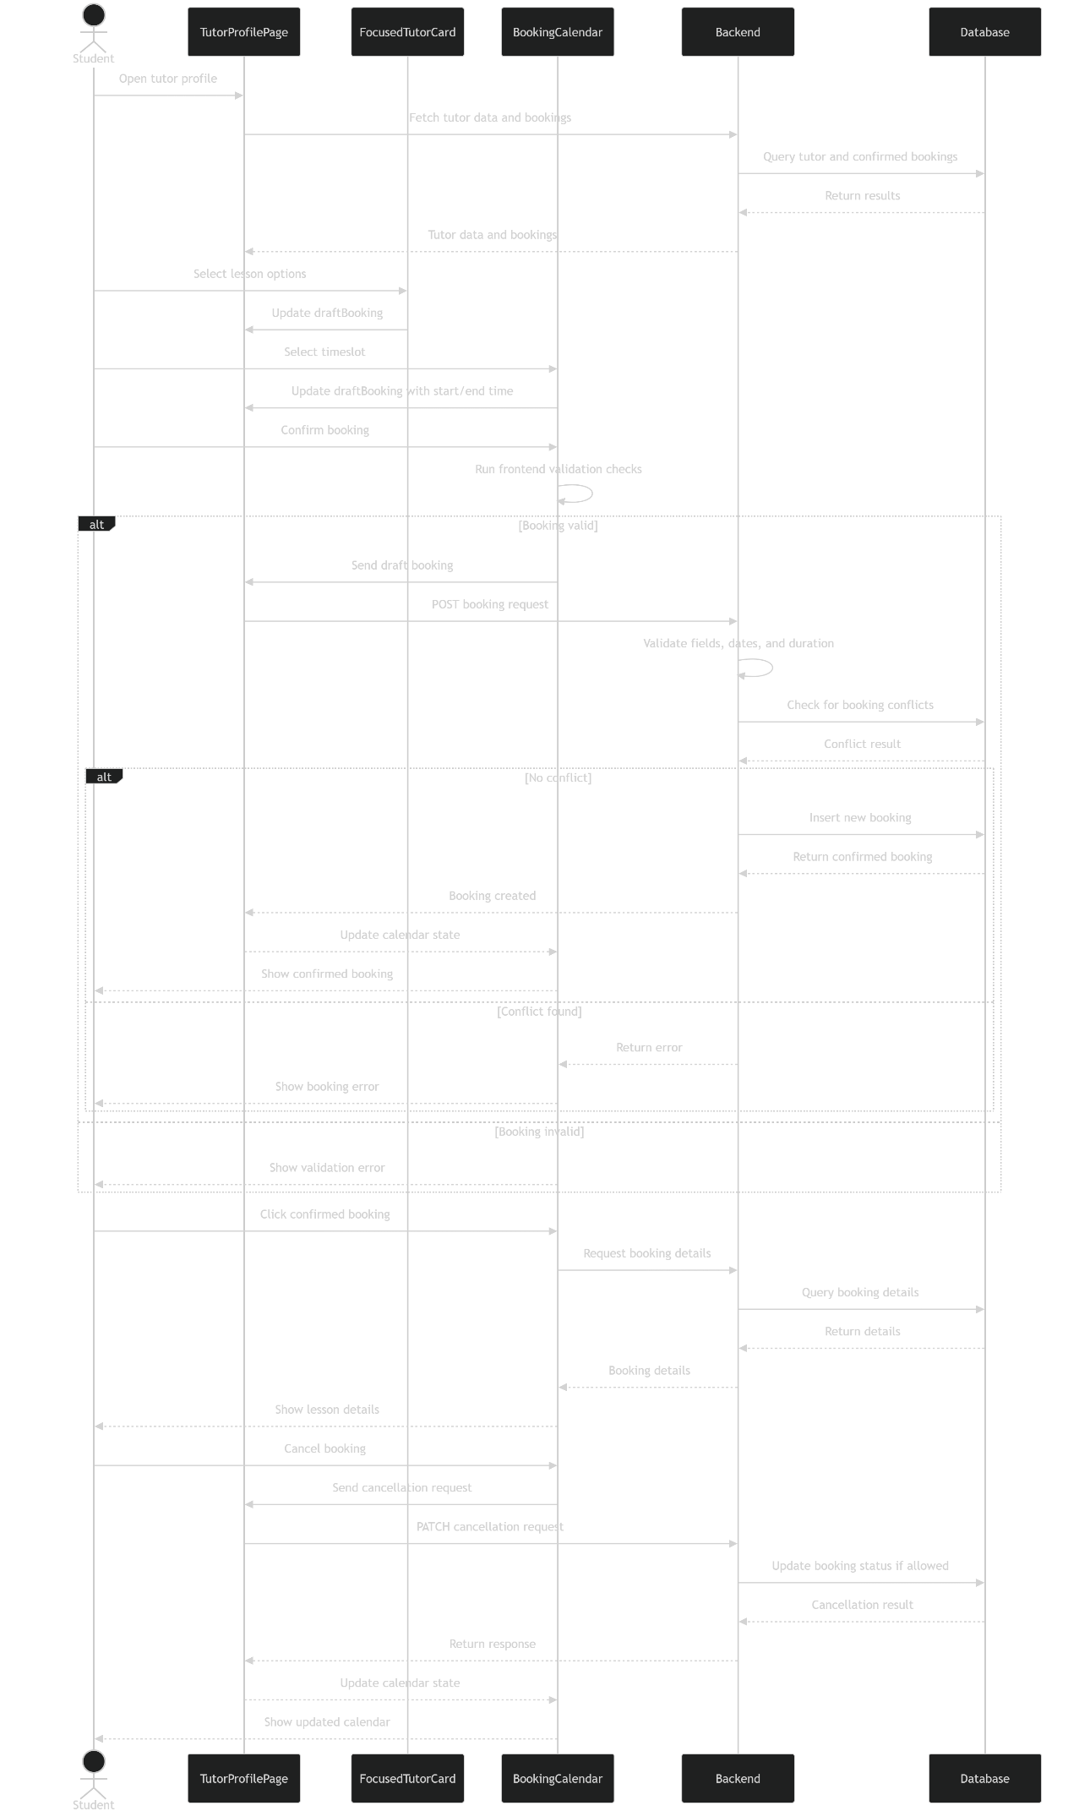
Fig 3.2: Lesson booking, confirmation, data retrieval, and cancellation

3.2.5 Real-time messaging [39,40,41,42,43,44,45,46,47,48]
The webchat system combines HTTP request-response and Socket.io. HTTP is used for authenticated retrieval of stored conversation history and inbox summaries from the database, and Socket.io handles real-time communication and instant notifications. This arrangement separates chat history from live interactions. The functionality is created through a series of complementary event listeners and emitters on front and back end. Listeners take the form socket.on() or io.on() and emitters socket.emit() or io.emit().
On the frontend, the Main.jsx component acts as the top-level component for real-time messaging functionality. It provides UserContext and ChatContext which allow user and chat state to be shared across the application and conditionally renders the ChatNotifier, ChatMessagesIcon, and MessagesDrawer components only if a user is logged in. Main.jsx also manages the socket.io client connection with a useEffect hook dependant on user login status. When a user logs in, the client connects using the app’s socket.mjs socket instance. When a user logs out, the socket disconnects. This ensures that real-time messaging is only available to authenticated users and that connections are not kept after logout.
Webchat authentication relies on the JWT stored in an HTTP-only cookie, but express and socket.io handle it differently. For HTTP requests, protected chat-history routes use the protect middleware which reads the token cookie from req.cookies, verifies it and retrieves the matching user from the database and attaches user info to req.user using the buildUserInfo function. Subsequent route controllers can treat the request as authenticated and access the user info for their own needs.
Because socket.io cannot access request and response objects, custom middleware is used. In server.mjs, the io.use() middleware reads the cookie from socket.handshake.headers.cookie, extracts the cookie payload, verifies it, and, as above, retrieves matching user info from the database and attaches it to socket.user using the buildUserInfo function. If no matching user is found, the connection is rejected. To support this authentication, the frontend’s socket instance is configured to send credentials during the handshake and not to autoconnect.
Once a socket has been authenticated, the backend’s io.on(‘connection’) handler uses the authenticated socket.user object to identify the logged-in user and to create a personalised, private room using their user id e.g. user:12 which is later used for notifying them in real-time of messages received from any other user. Crucially, the server also initialises socket.data.dmPeers which is used to store the direct-message room names and chat recipient user id for student and tutor chat pairings. While the socket is connected, this keeps a record of the rooms and recipients a user has been having conversations with since login.
A conversation room is created only when the student opens a chat window in the frontend via the ‘message tutor’ button in the FocusedTutorCard component. The button is only available if a student is logged in and, when clicked, opens the ChatWindow component. Once opened, this component emits the join_room event, sending the intended recipient/tutor’s user id (loaded in FocusedTutorCard’s initial render) labelled as otherUserId. The socket server listens for this event, obtains the logged-in user’s user id via socket.user and the other user/chat recipient’s id from otherUserId, runs validation to prevent self-chat, and generates a permanent, unique room name by ordering the logged-in user and recipient user ids from lowest to highest. The room name is generated this way so both participants in a chat resolve to the same room name. The logged-in user’s socket then joins that room and the room number and recipient/other user id are stored in socket.data.dmPeers as key-value pairs. Finally, the server emits the room name back to the frontend where it is stored in the ChatWindow component state and used to direct the component’s subsequent chat messages to the correct room via its emitted chat_message event.
In parallel with joining a live room, ChatWindow component fetches any historical messages for the same chat pair by sending an HTTP request. This request is handled by the protected getMessagesFromDB controller which uses req.user and req.params.otherUserId to identify the participants, arranges the ids in ascending order, and checks if a room for that chat pair is stored in the database. If a matching room is found, its messages are loaded from the database and rendered in the frontend ChatWindow via state. If no room is found, an empty array is returned.
For message persistence, when a user sends a message from ChatWindow, the component’s handleSend function validates that the message is not empty and that a room name has been received from the backend. It then emits the chat_message event containing the room name and trimmed message text to the server. For security, the component does not send user or recipient user ids; instead, the backend again derives the ids from the socket.user and socket.data.dmPeers objects.
When the backend receives the component’s chat_message event, its chat_message event handler validates that the socket is a member of that room. It then derives the user and recipient ids as described above, and uses the room name sent back from the client. The handler then uses an UPSERT query so the room name is only stored if it doesn’t already exist and then the room_id is returned. This reduces calls to the database as the logic is handled in one query rather than check-then-insert queries.
The returned room_id is then used to insert the message text into the chat_messages table along with sender user id, recipient user id and room id. At this insert, the database returns a message_id, a sent_at timestamp and the room_id which are then used to backfill the chat_rooms table’s relevant room_id row with the message_id and sent_at timestamp. This backfilling enables the inbox-summary functionality described below. Once the message has been saved, the backend creates a message object and emits it to the frontend via io.to(room).emit() so that both parties in the room receive the message. Finally, to support notification, a truncated message object is sent to the recipient’s personal room via io.to(`user:${recipientUserId}`).emit('incoming_chat').
On the frontend, ChatWindow component listens for server-emitted chat_message event and adds the payload message to its messages state array. Because the component has the socket event listener for real-time messages and a separate fetch of chat history from the database running in parallel, there is a chance that a live message could arrive during the fetch and then be either lost from or duplicated in the UI when the fetch response lands and is rendered by updating the messages state. It would be lost if the fetch completed before the message was written to database prior to its emit event, and duplicated if it was written to database, rendered in UI, and then read again in the fetch. Consequently, the useEffect code merges the pre- and post-fetch messages state (to preserve a message that was in UI during fetch but not yet written to database when the fetch queries it) and removes potential duplicates (for the case where the message was in UI during fetch but was also in the database when queried). This ensures that both participants see a coherent message timeline.
For real-time notification outside of a chat window, the server also emits an incoming_chat event to the recipient’s personal room that was created post-login in the io.on(‘connection’) listener. The event emits the sender’s user id, name, and a message preview. On the frontend, the ChatNotifier component listens for the incoming_chat event. When received, it validates the payload and checks if the recipient is currently in an active ChatWindow with the sender. If so, no notification is shown; if not, a popup appears on screen displaying sender’s name, message preview, and gives the option to open a ChatWindow or dismiss. Clicking ‘open’ updates the activeChat state in the ChatContext and displays the window onscreen. The ChatWindow fetches conversation history as described above.
The use of socket.io and HTTP, combined with state-based conditional rendering and use of React Context, allows app-wide, authenticated, real-time notification and webchat

References
Chapter 1
1: https://musicteachers.co.uk/
2: https://musicteacher.com/
3: https://www.firsttutors.com/uk/music/

Chapter 3
1: https://socket.io/docs/v4/how-it-works/

